POCONO OLD-TYME FARM EQUIPMENT ASSOCIATION’S

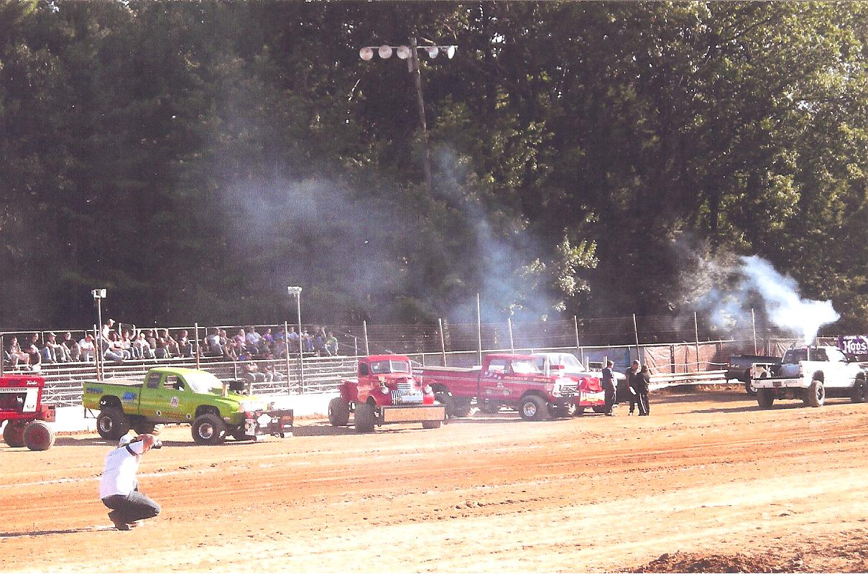

4 X 4 TRUCK PULL
SATURDAY–JULY 11, 2015
5:00 PM
WEST END FAIRGROUNDS * JUST OFF OF ROUTE 209 * GILBERT, PA

$5.OO GRANDSTAND ADMISSION PLUS $2.OO GATE ADMISSION TO OUR 20TH ANNUAL ANTIQUE TRACTOR, GAS ENGINE & FARM EQUIPMENT SHOW

TRUCK REGISTRATION FROM 1:00 – 4:00 PM

WEIGHT CLASSES ARE:
5800 & 6500 LBS STREET LEGAL (TRUCK CAN ONLY PULL IN ONE CLASS)
6200 LBS PRO STOCK (CAN PULL TWICE)
6500 LBS MODIFIED
8000 LBS DIESEL STREET LEGAL (WORK STOCK)
2.6 TURBO STREET DIESEL

TROPHIES AND MONEY AWARDED

DUE TO INSURANCE PURPOSES ALL TRUCK PULLERS MUST BE A MEMBER OF POCONO OLD-
TYME FARM EQUIPMENT ASSOCIATION. FOR RULES OR INFORMATION CALL 570-992-2245, 610-759-7647 OR 570-402-7333 OR GO TO OUR WEB SITE AT WWW.POCONOOLDTYME.COM

IN CASE OF INCLEMENT WEATHER CALL 570-402-7333 FOR CANCELLATIONS. NO RAIN DATE.

